Fingerprint based on ATM System

All existing banking applications are authenticating users based on PIN NO or password but this technique is not secured so in propose online banking application we are authenticating user based on his finger print. To implement this project we have designed following modules

1. Signup: using this module user can signup with the application by using username, password and finger print image. All signup details will be saved in MYSQL database
2. Login: using this module user can login to application by entering username, password and finger print image given at signup time to authenticate himself
3. Deposit: after successful authentication user can deposit amount and it will added to his account
4. Withdraw: using this user can withdraw amount if sufficient balance available
5. View Balance: using this module user can view available balance

First create database in MYSQL by copying content from ‘DB.txt’ and then paste in MYSQL

To run project double click on ‘run.bat’ file to start python FLASK server

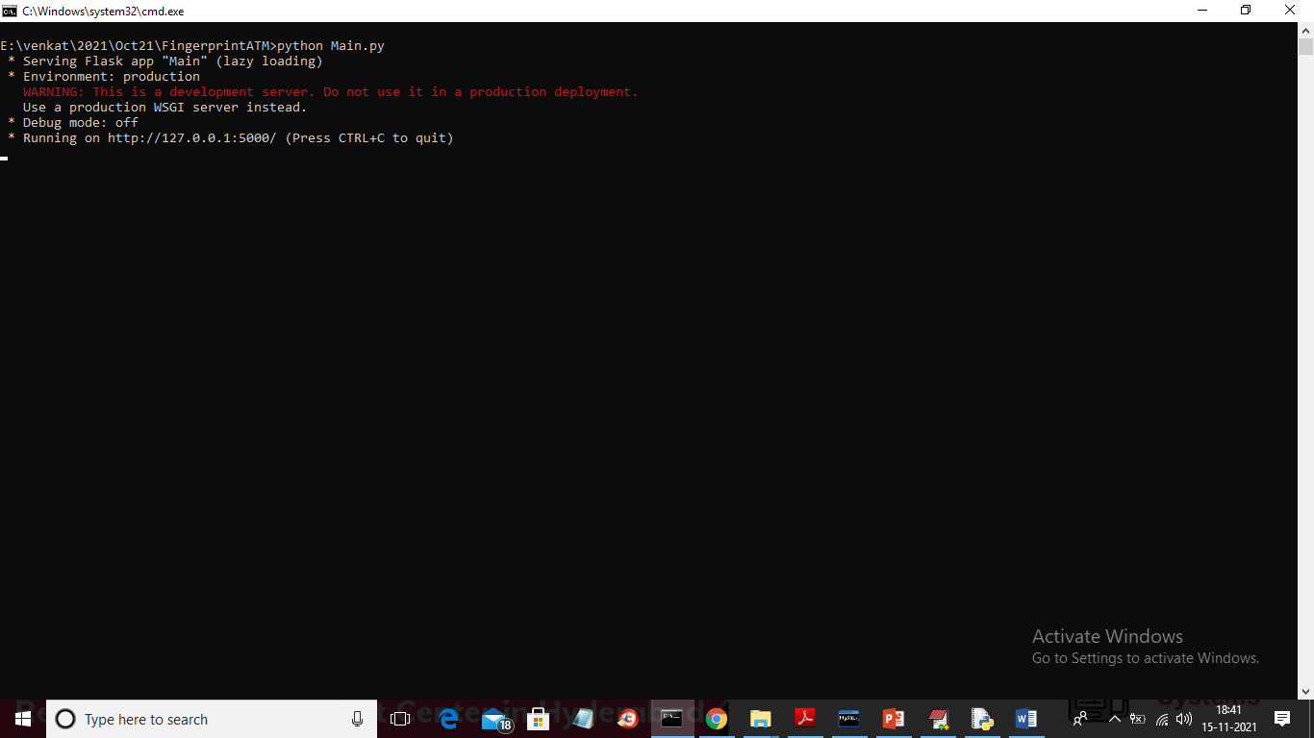

In above screen server started and now open browser and enter URL as ‘http://localhost:5000/index’ and press enter key to get below home page

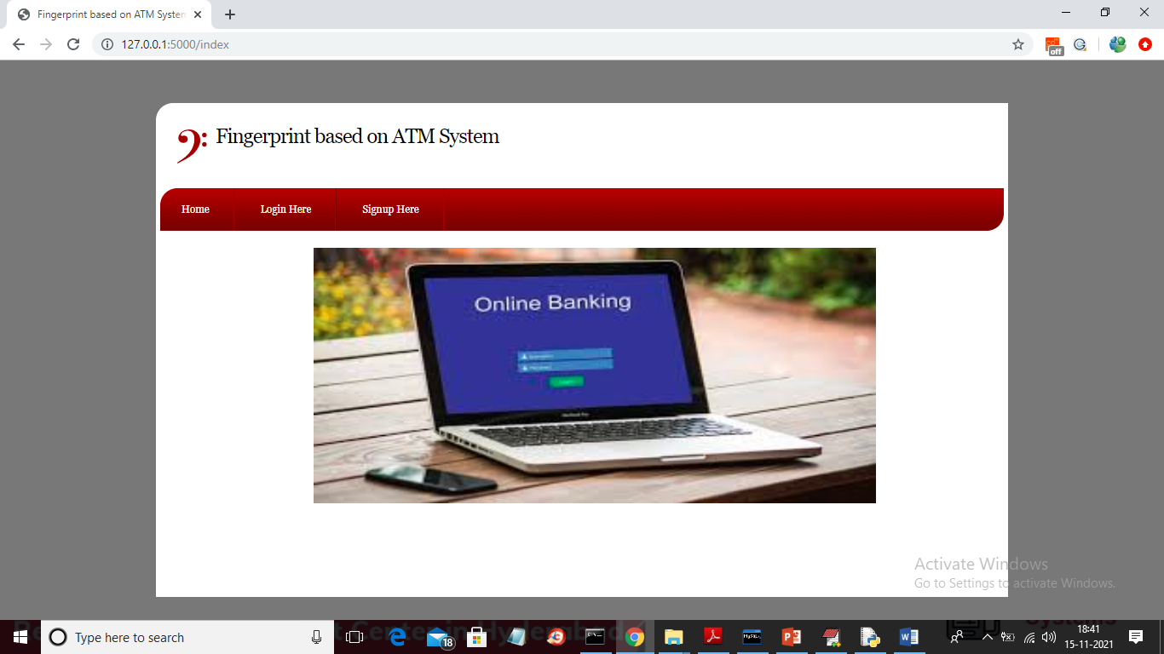

In above screen click on ‘Signup Here’ link to get below screen

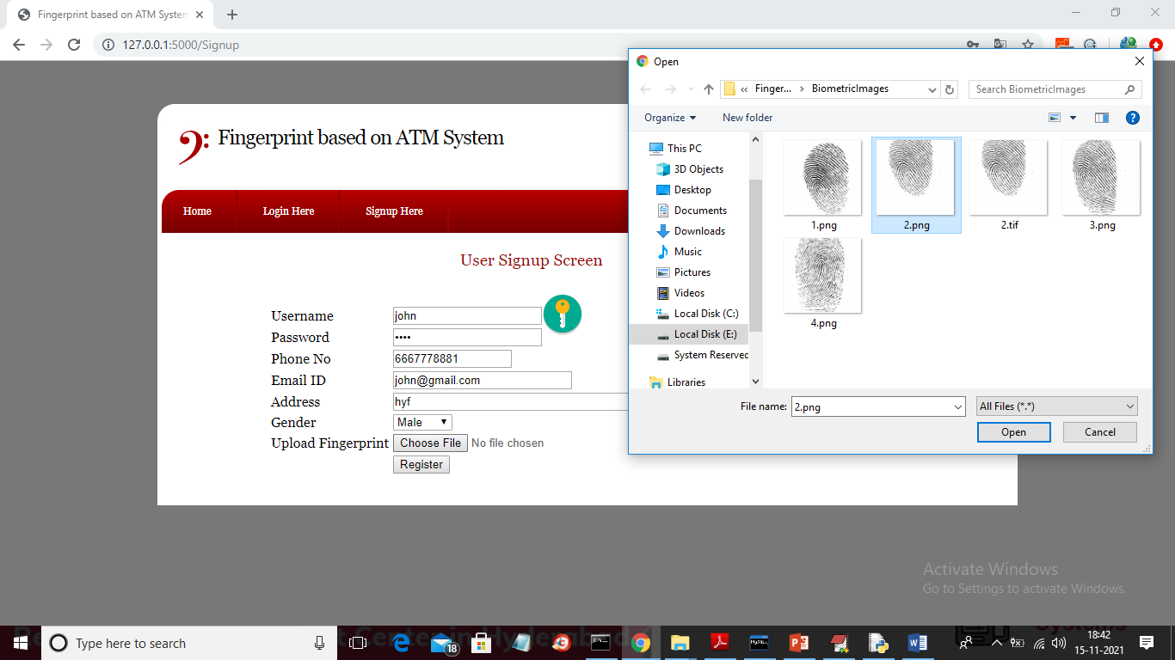

In above screen fill all signup details and then choose finger print image and then click on ‘Open’ button to load image and to get below screen

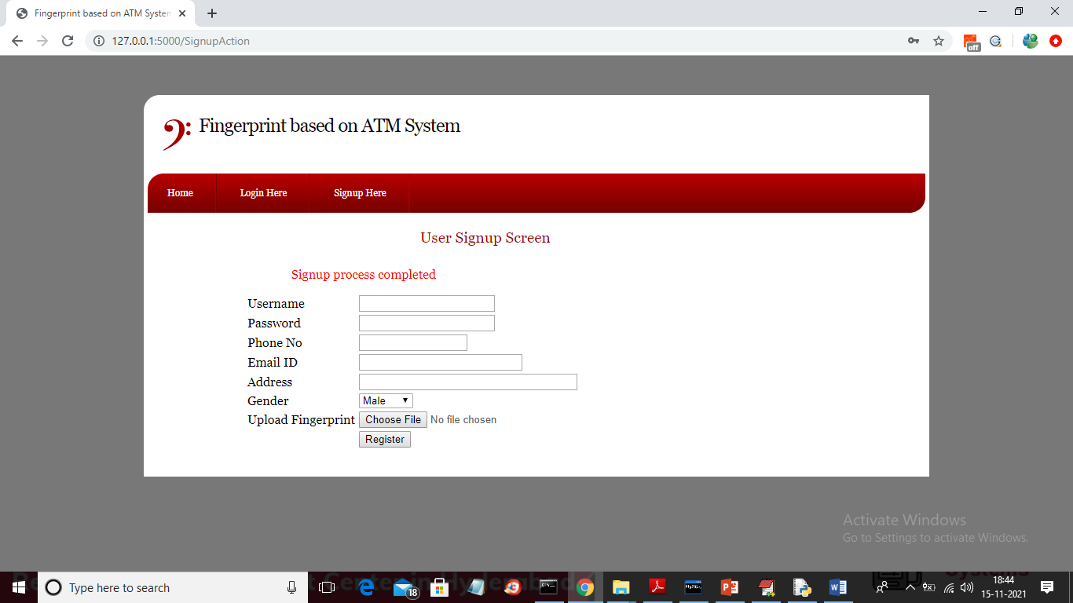

In above screen after pressing ‘Register’ button we will get message as ‘Signup process completed’ and now click on ‘Login Here’ link to get below screen

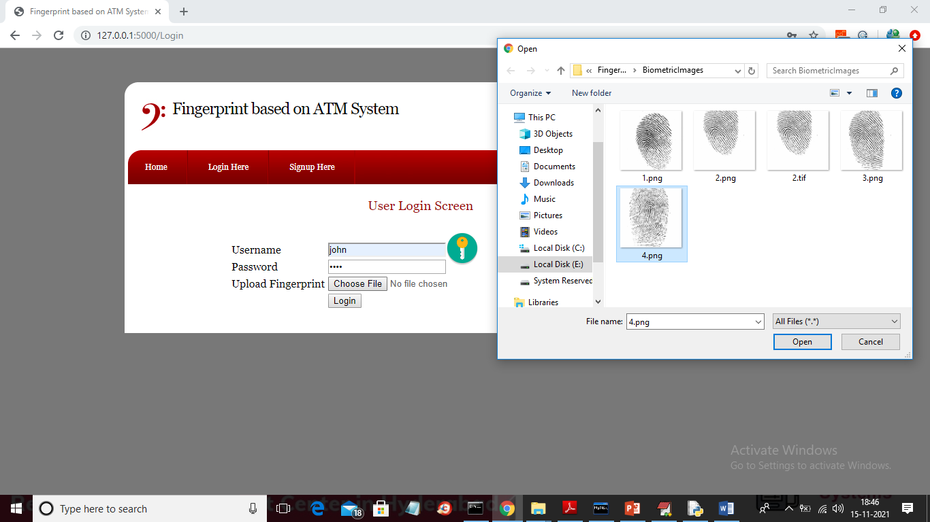

In above screen I am login and selecting wrong finger print as ‘4.png’ and then click on ‘Open’ button to get below screen

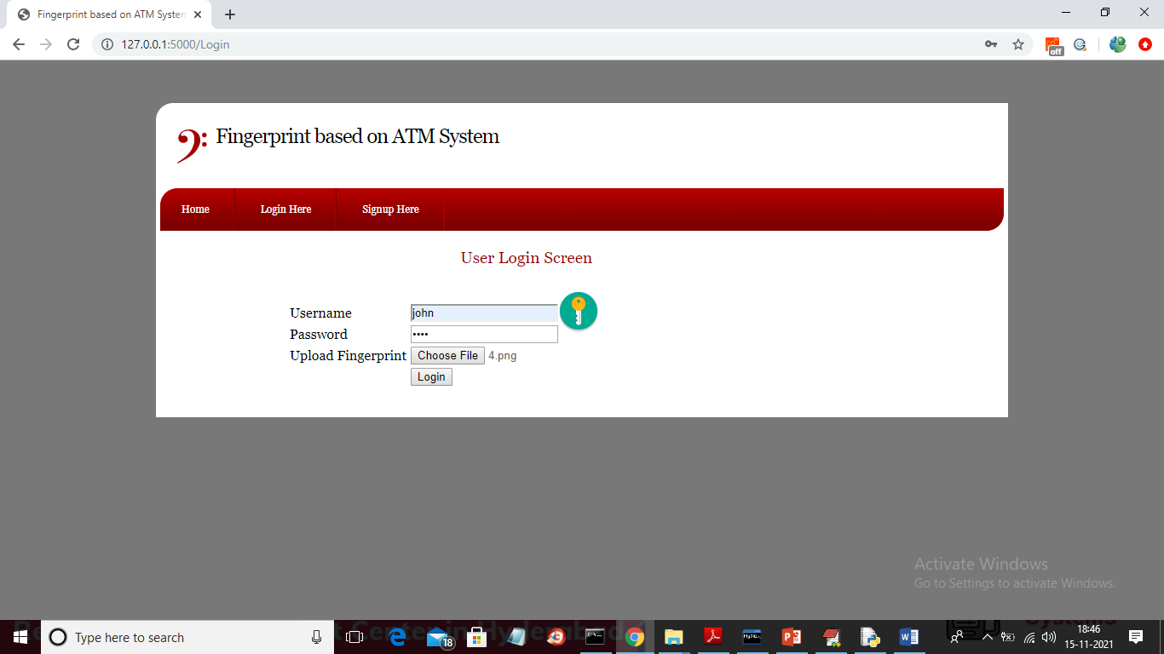

In above screen image loaded and now click on ‘Login’ button to get below output

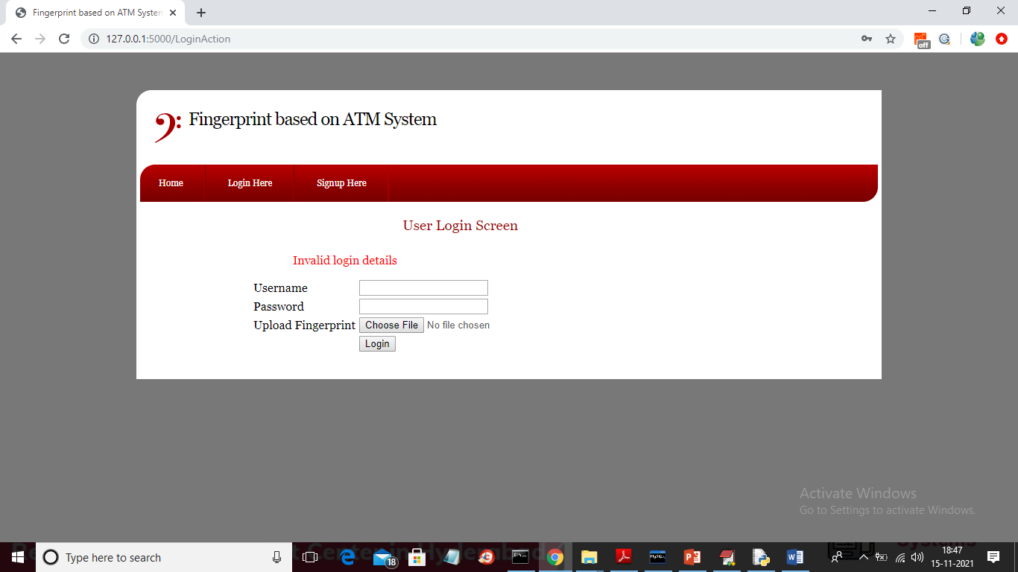

In above screen login is failed and now login with correct image

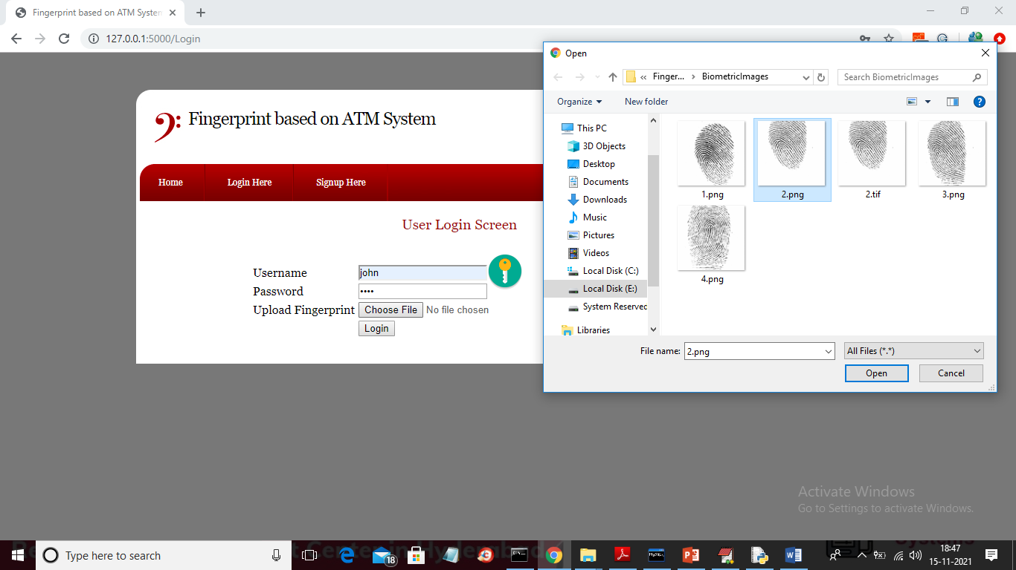

In above screen now i am uploading correct image and press ‘Login’ button to get below output

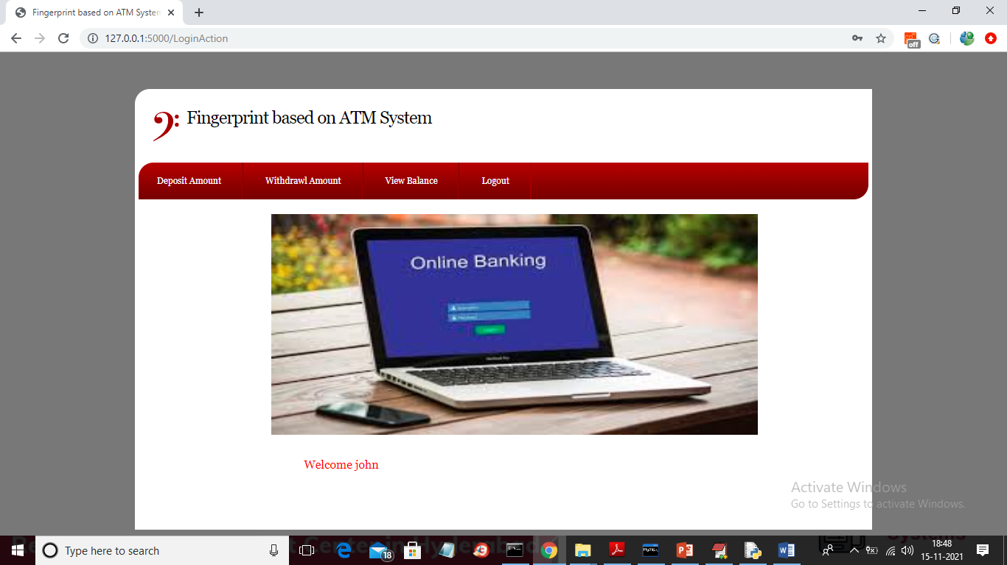

In above screen user login is successful and we got deposit and with draw option. Now click on ‘Deposit Amount’ link to get below screen

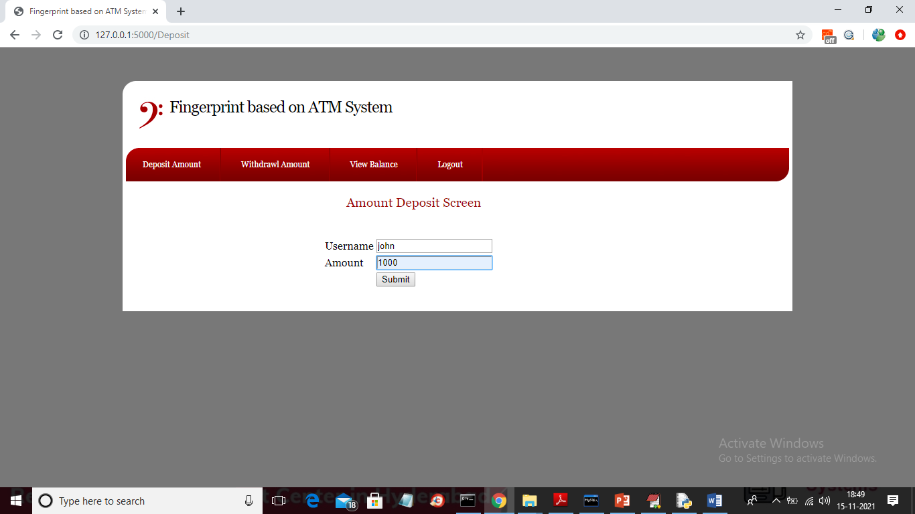

In above screen username will display in default and now enter some amount and press ‘Submit’ button to complete transaction and will get below output

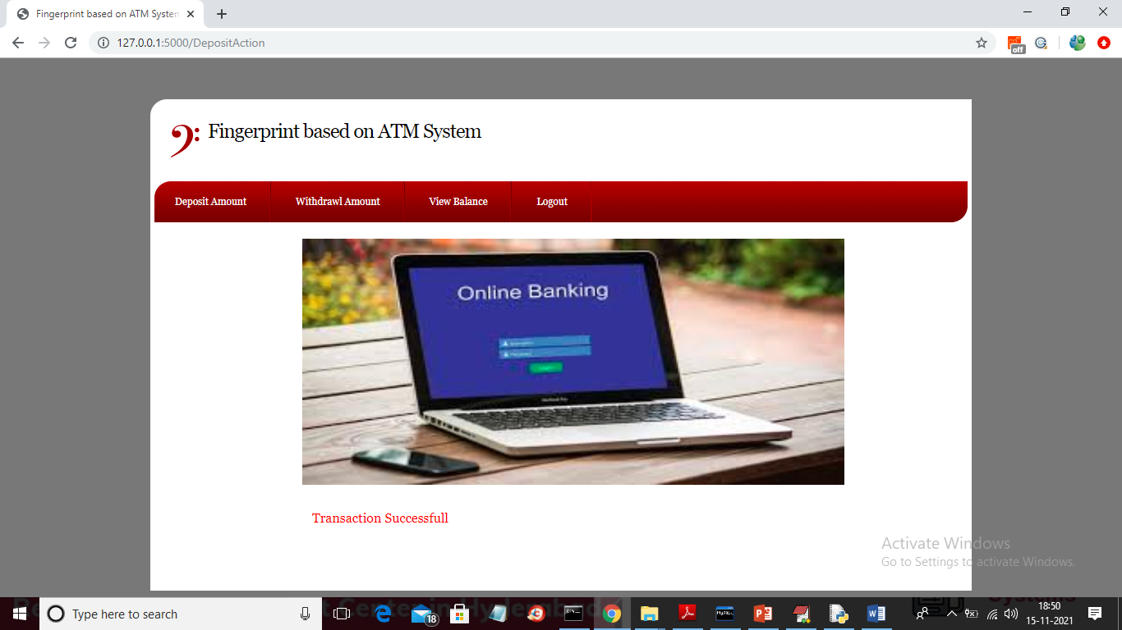

In above screen we can see transaction is successful and now click on ‘View Balance’ link to view balance

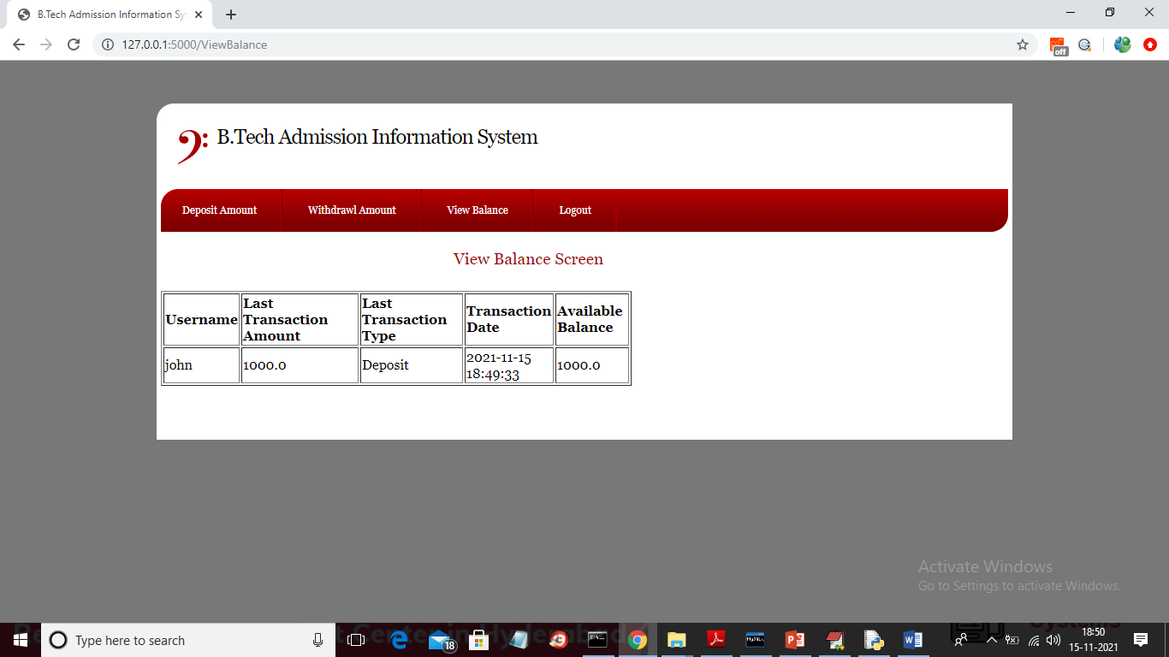

In above screen deposit transaction is displaying and now click on ‘Withdrawl Amount’ link to get below screen

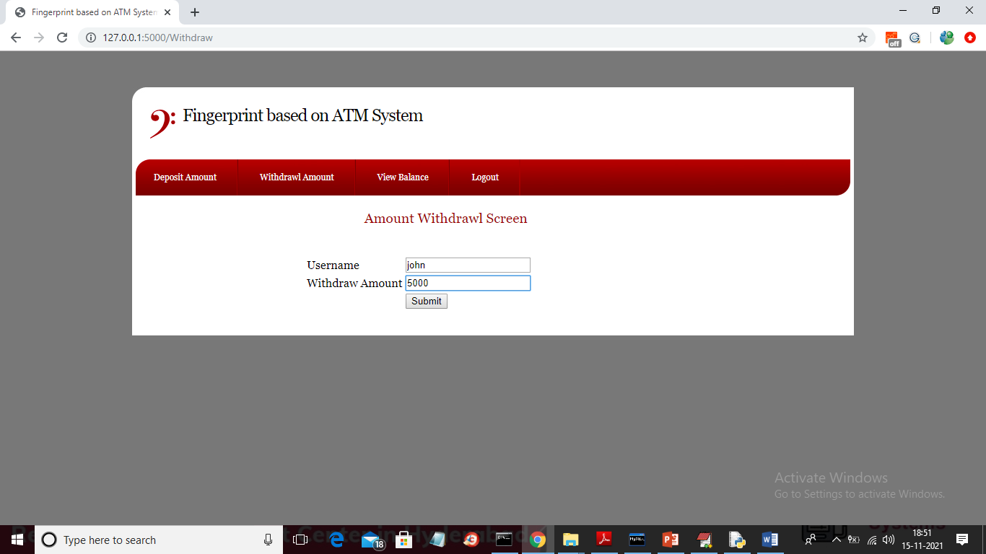

In above screen I am withdrawing amount larger than available amount to get below screen

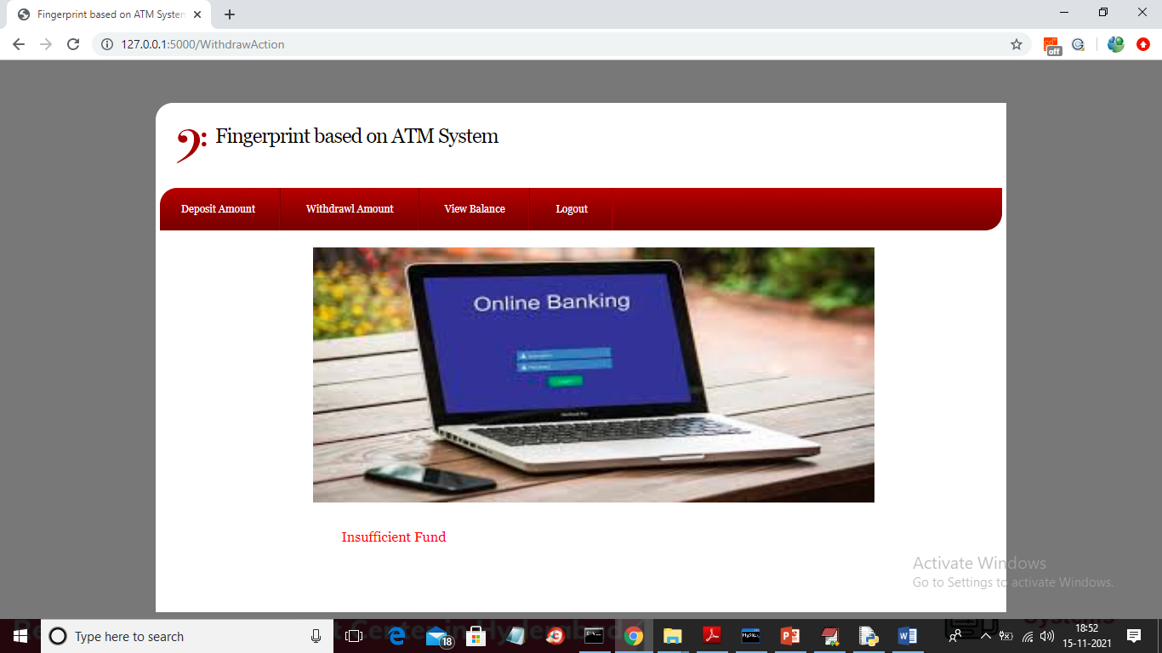

In above screen we can see ‘Insufficient Fund’ and now withdraw another amount

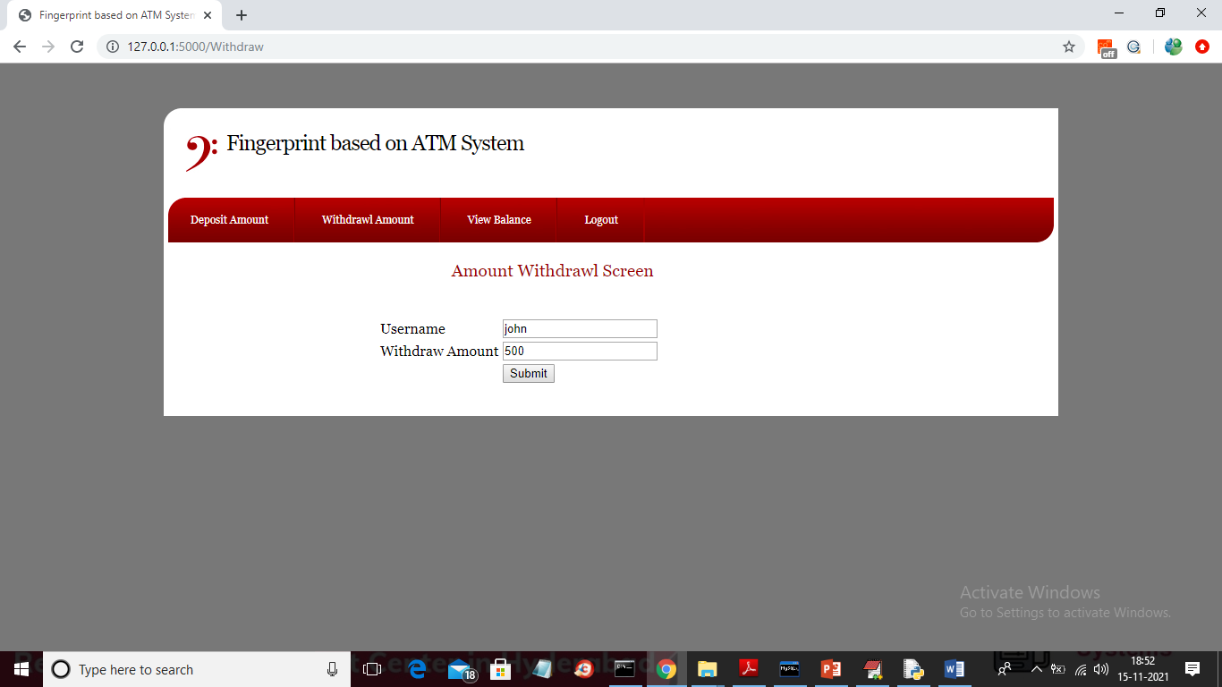

In above screen 500 is withdrawing and press ‘Submit’ button to get below screen

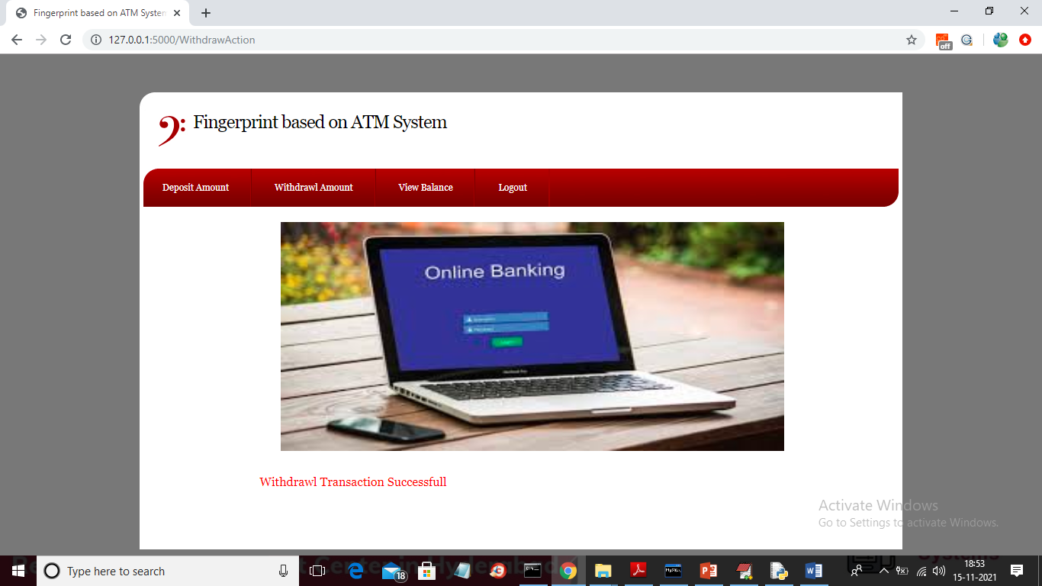

In above screen withdraw transaction successful and now check balance again

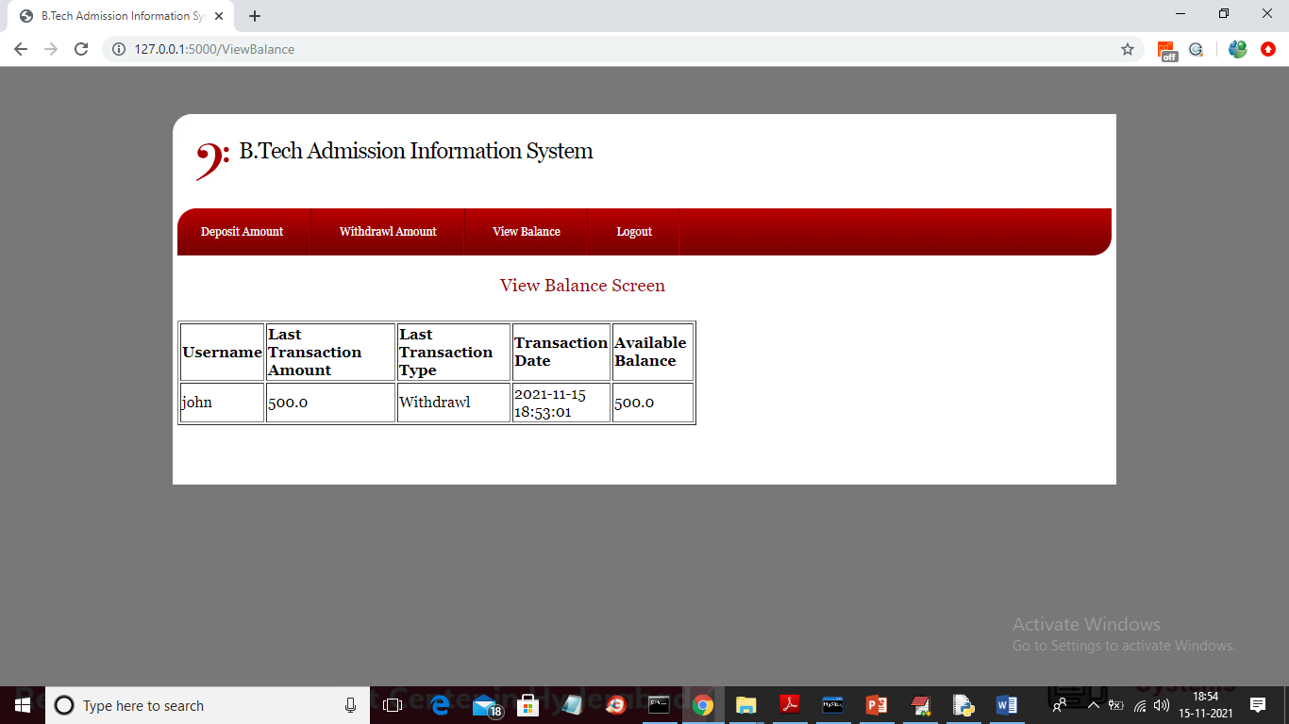

Now in above screen available balance is 500. Similarly you can perform N number of transaction